Title
Sphero Amazing Labyrinth

Grade
Grade 6

Subject
Math and ADST
Big ideas
Math: Properties of objects and shapes can be described, measured, and compared using volume, area, perimeter, and angles.

ADST: Design can be responsive to identified needs.
Complex tasks may require multiple tools and technologies.

Cross Curricular
Covers Math and ADST

Core Competency
Communication:
Working with others to achieve a common goal.
Presenting Information in an organized way.
Creative Thinking:
Building on other people’s ideas, creating new things within the constraints of a form, a problem, or materials.
Using experiences with various steps and attempts to direct future work
Personal and Social:
Persevering with challenging tasks.
Social Responsibility:
Being part of a group.
Developing and maintaining diverse, positive peer relationships.

Curricular Competencies
Math:
Use reasoning and logic to explore, analyze, and apply mathematical ideas
Use tools or technology to explore and create patterns and relationships, and test conjectures
Develop, demonstrate, and apply mathematical understanding through play, inquiry, and problem solving
Communicate mathematical thinking in many ways
Represent mathematical ideas in concrete, pictorial, and symbolic forms
Connect mathematical concepts to each other and to other areas and personal interests
ADST:
Generate potential ideas and add to others’ ideas
Construct a first version of the product or a prototype, as appropriate,
making changes to tools, materials, and procedures as needed

Lesson Topic/Theme
Students will create a 3D obstacle course using cardboard and other materials for spheros to navigate through. They will calculate the angles of all the corners and the distance

Suggested Activity/Unit Concept
Students should be encouraged to bring materials from home and you can supply them with cardboard, masking tape, Bristol board, rulers, protractors, markers, maker cart supplies, spheros and handheld devices.

Begin the lesson by having the students co-create a criteria. Encourage students to add anything that they have learned in Math about angles, have the sphero say the angles as it goes around them. Then provide students with time to create a labyrinth to navigate their sphero through.

Afterwards students can be challenged to work on each others.

Tags/Keywords
Sphero, angles, protractor, right angle, obtuse angle, coding, obstacle course

General Comments
Before this lesson students should know how to code the spheros.
They should also know how to calculate angles.

Resources:

Print
- Title
The Big Book of Makerspace Projects

- Image
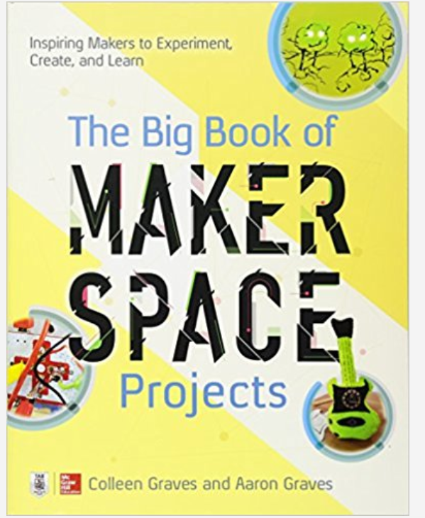

- Curriculum Connection
This book has many ideas for projects that link with the Creative Thinking Competency and Critical Thinking

- Aboriginal Connection

- ERAC Evaluation
https://k12.bcerac.ca/resource/?q=Big-Book-of-Makerspace-Projects-The-Inspiring-Makers-to-Experiment-Create-and-Learn&ResourceTitleID=7548

- Notes

Curated Website
- Title

- Image

- Curriculum Connection

- Aboriginal Connection

- ERAC Evaluation

- Notes

BC Digital Classroom Core Collection
- Title

- Image

- Curriculum Connection

- Aboriginal Connection

- ERAC Evaluation

- Notes

BC Digital Classroom a la carte
- Title

- Image

- Curriculum Connection

- Aboriginal Connection

- ERAC Evaluation

- Notes

Choose from your District Recommended Collection
- Title
Sphero (Matteson), Coding with Sphero (Matteson), Ancient treasure mazes (Phillips) — Mazes: perimeter and area (Beth) — Curling (Labrecque) — Math with cars and trucks: measurements and estimation — A day at mini-golf: what’s the length — Curling (Throp) — Race cars (Crane) — Extreme parks: angles (D’Alessandro) — Formula 1 cars (Bodensteiner) — Build your own mini golf course, lemonade stand, and other things to do — Creating with cardboard (Quinn)

Websites and Apps:
http://www.learn71.ca/wp-content/uploads/2018/08/SpheroEdu-k12-teacher-resource-guide-v1_updated050818.pdf - Sphero created lessons

https://edu.sphero.com/ - Sphero Lightning lab app

https://andyjacks.co/2016/05/25/sphero-ideas-for-teachers/ - Obstacle course ideas

- Image

- Curriculum Connection

- Aboriginal Connection

- ERAC Evaluation

- Notes

